**Second Payment Reminder**

To whom it may concern,

Recently, we got in touch to remind you of the pending amount on your most recent invoice. As another reminder, payment was due 14 days ago.

If you have any queries regarding this payment, please let us know. Your invoice is available under the reporting tab within the Irish Life Health Live portal.

To ensure that the members of your group scheme are always fully covered, it is very important that your premium is paid as soon as possible.

If the payment has already been sent, please disregard this notice.

If you have any questions, please contact us by calling the Corporate Accounts team on 01 5625303 (Monday–Friday,9am–5pm) or by email corporate.accounts@irishlifehealth.ie and we’d be happy to help.

Yours sincerely,

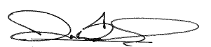

Darran Bennis

Senior Manager– Commercial Operations